**Practical 8**

**Implement and demonstrate the use of following in solidity**

**LOOPS**

Loops : do while

pragma solidity ^0.8.0;

contract Types{

    uint[] data;

    uint8 j=0;

    function loop() public returns(uint[] memory){

        do{

            j++;

            data.push(j);

        }

        while(j<5);

        return data;

    }

}

Deploy:

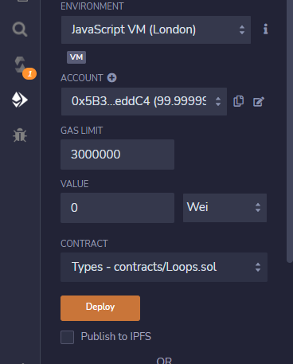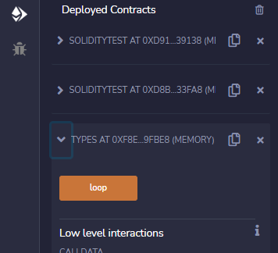

Output :



Loops : while loop

pragma solidity ^0.8.0;

contract Types{

    uint[] data;

    uint8 j=0;

    function loop() public returns(uint[] memory){

        while(j<10){

            j++;

            data.push(j);

        }

        return data;

    }

}

Deploy :

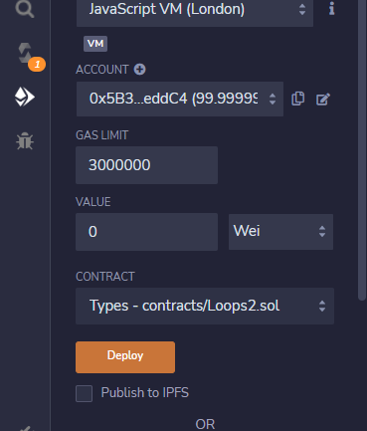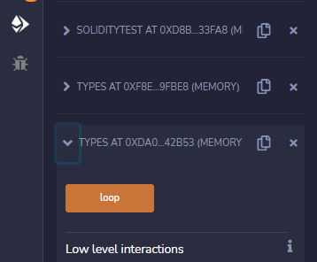

Output:



Loops : for

pragma solidity ^0.8.0;

contract ForTest{

    uint[] data;

    function loop() public returns(uint[] memory){

        for(uint i=0;i<5;i++){

            data.push(i);

        }

        return data;

    }

}

Deploy:

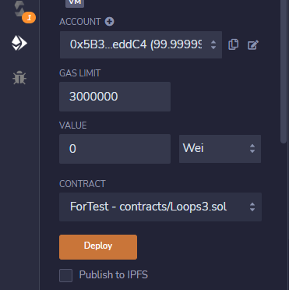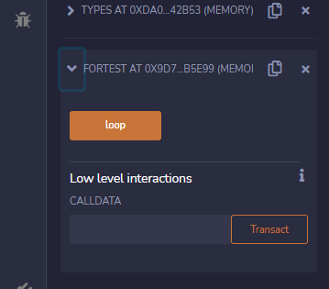

Output:

